Cloud Guard with ORM Stack

Contents

1. Introduction 1
2. Workflow diagram to deploy the stack 2
3. Pre-requisites 2
4. Create Stack for Cloud Guard 3
5. Create Cloud Guard Configuration 4
6. Plan the Job 7
7. Apply the Job 7
8. Verify in the Console 9
9. Follow 2 steps to destroy the Cloud Guard 10

Introduction

Cloud Guard is a cloud native service that helps customers monitor, identify, achieve, and maintain a strong security posture on Oracle Cloud.

This helps automatically identify and remediate security problems. This resource enable/disable Cloud Guard. The reporting region cannot be updated once created.

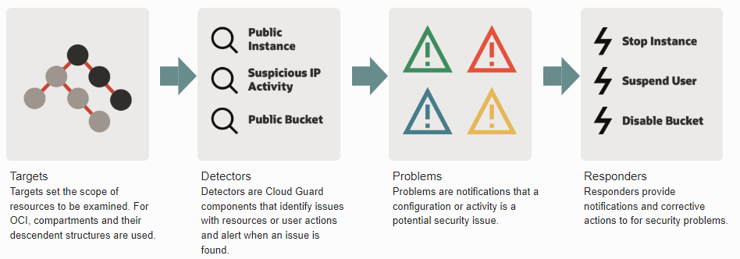

- Detects misconfigured resources and identifies risky activities.
- Delivers out-of-the-box recipes that apply security best practices with a few clicks.
- Provides automated responders to trigger corrective actions.
- Gives a global view of customer's overall security posture of their OCI tenancy, including security and risk scores and activity maps.

Also it creates a new policy in the specified compartment, either the tenancy or another of your compartments.

Workflow diagram to deploy the stack

Below diagram shows how the Terraform Artifact are applied in the OCI. While creating a ORM stack, using terraform deliverables Init, Plan and Apply is the flow to provision the resource in the OCI. We can have the deliverables in any of below.
- GitLab/GitHub Repo
- Bitbucket
- Can be in folder/.zip in the local disk
- Object Storage Bucket
- Can be in compartment
- Oracle provided Template


Pre-requisites

- Below is the policy will be created for the cloud guard
"Allow service cloudguard to read keys in tenancy",
"Allow service cloudguard to read compartments in tenancy",
"Allow service cloudguard to read compute-management-family in tenancy",
"Allow service cloudguard to read instance-family in tenancy",
"Allow service cloudguard to read virtual-network-family in tenancy",
"Allow service cloudguard to read volume-family in tenancy",
"Allow service cloudguard to read tenancies in tenancy",
"Allow service cloudguard to read audit-events in tenancy",
"Allow service cloudguard to read vaults in tenancy",
"Allow service cloudguard to read object-family in tenancy",
"Allow service cloudguard to read load-balancers in tenancy",
"Allow service cloudguard to read object-family in tenancy",
"Allow service cloudguard to read groups in tenancy",
"Allow service cloudguard to read dynamic-groups in tenancy",
"Allow service cloudguard to read users in tenancy",
"Allow service cloudguard to read database-family in tenancy",
"Allow service cloudguard to read authentication-policies in tenancy",
"Allow service cloudguard to read policies in tenancy",
"Allow service cloudguard to read data-safe-family in tenancy",
"Allow service cloudguard to read autonomous-database-family in tenancy"
- The Cloud Guard option should be in “Disabled” state.
- Cloud Guard is not available for free OCI tenancies

Create Stack for Cloud Guard

Go to OCI Console Developer Services Resource Manager Stacks select the compartment Create Stack

My Configuration Folder Browse Select the “Cloud Guard” folder that contains the artifacts Upload

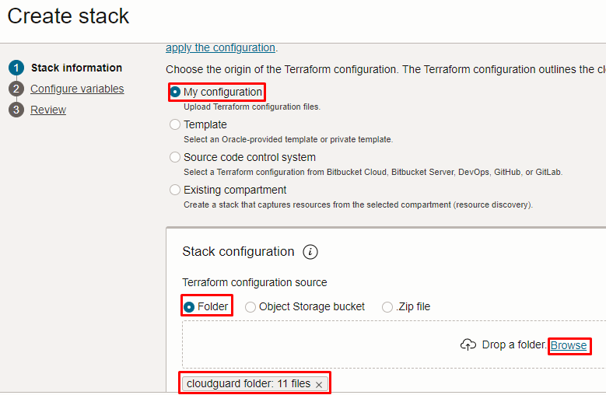

Select the parameters as per the below screen,

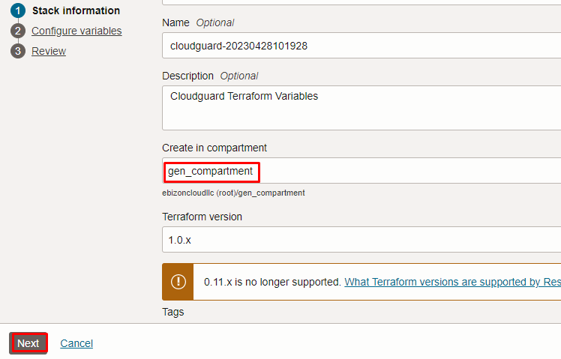

Click “NEXT”

Create Cloud Guard Configuration

Select the parameters as per the below screen,

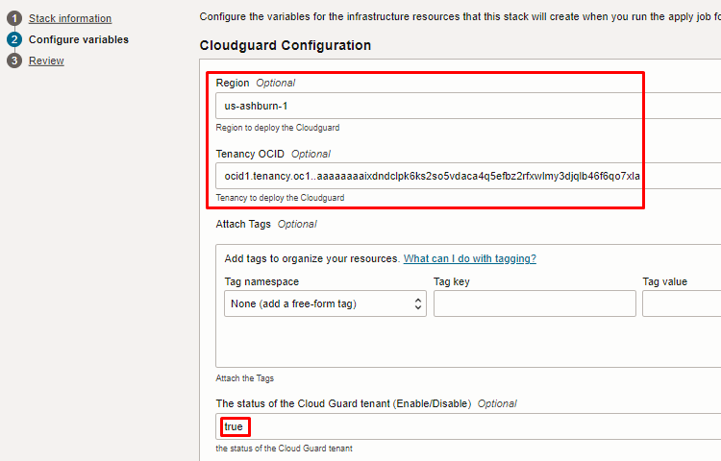

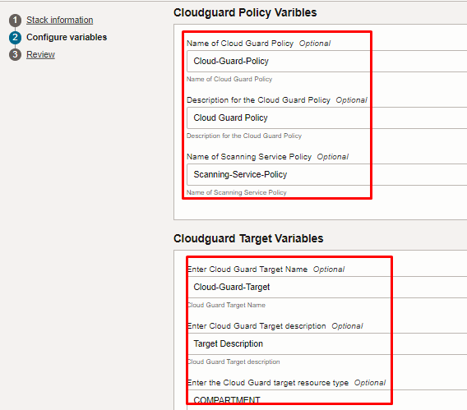
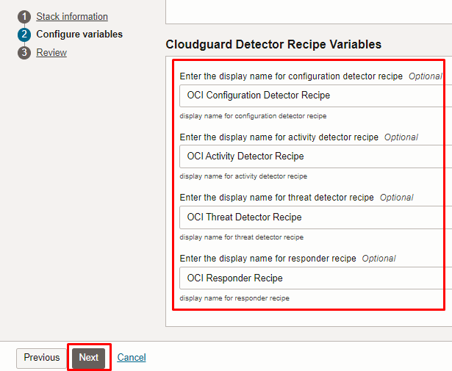

Click “NEXT”

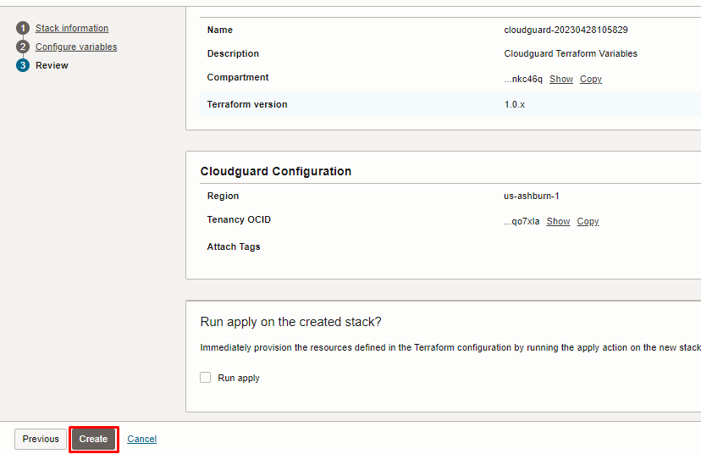

Click “CREATE”

Plan the Job

Click the “Plan”

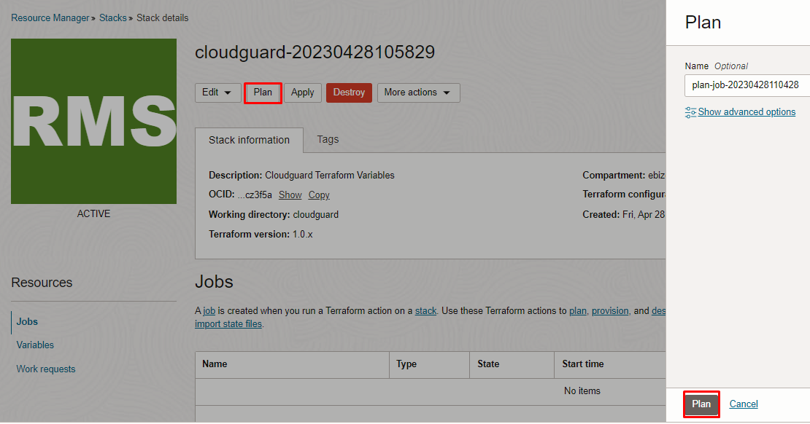

Verify the Plan is successful.

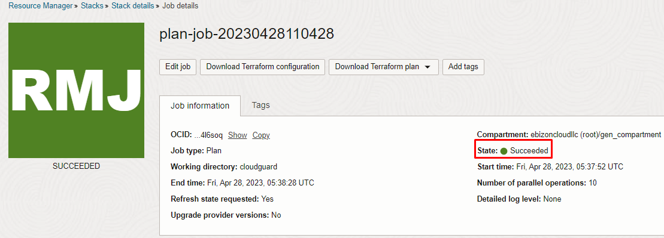

Apply the Job

Once the “plan” is success, now click “Apply”

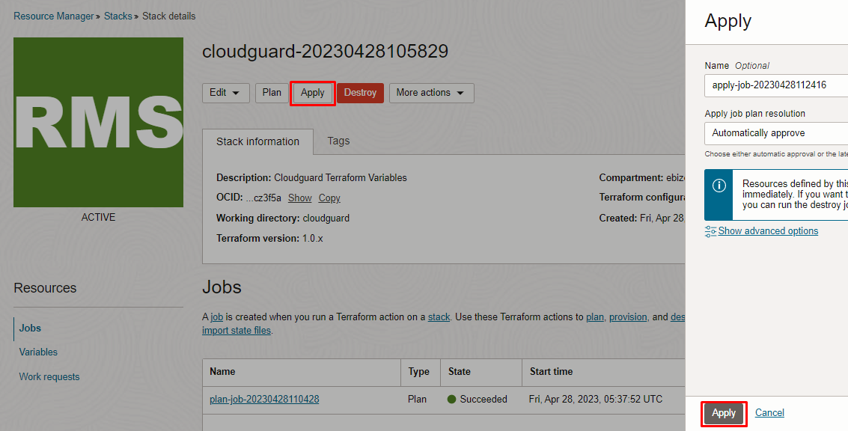

Verify the Apply is successful.

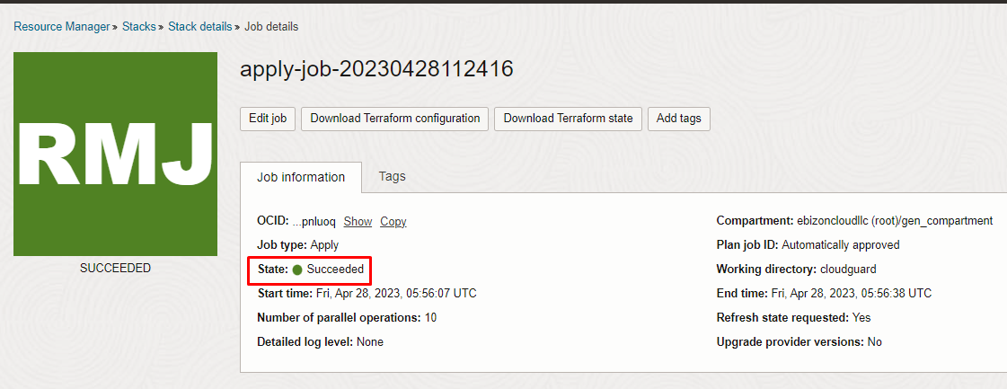

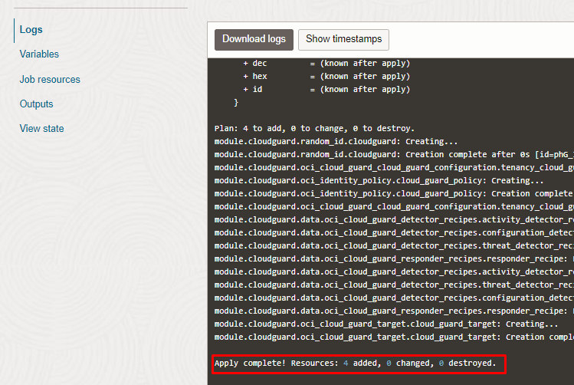

Verify in the Console

Go to OCI Console Identity & Security Cloud Guard Overview

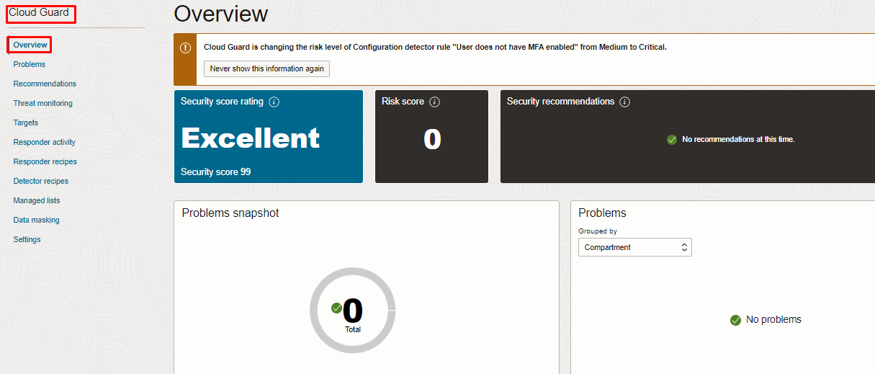

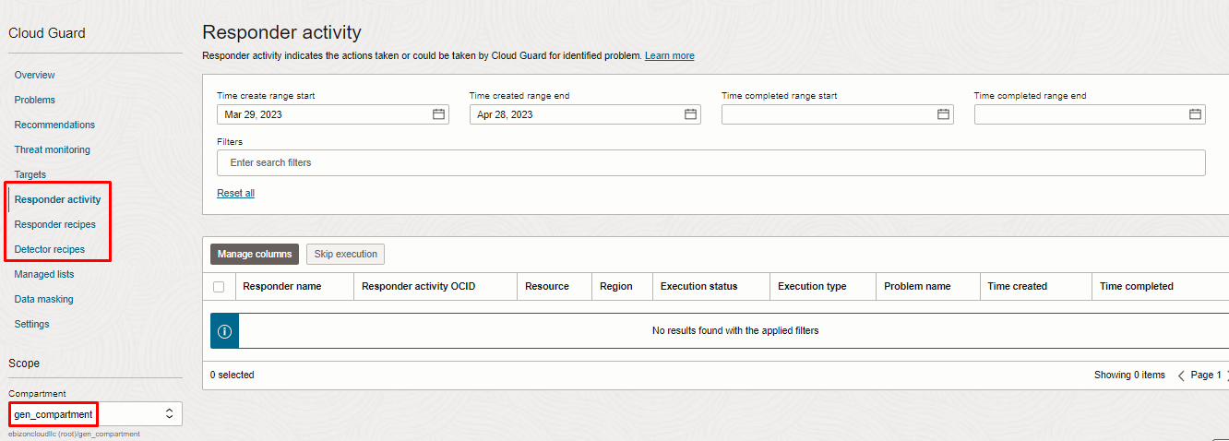

To Verify the Policies: Go to OCI Console Identity & Security Policies (select the root compartment)

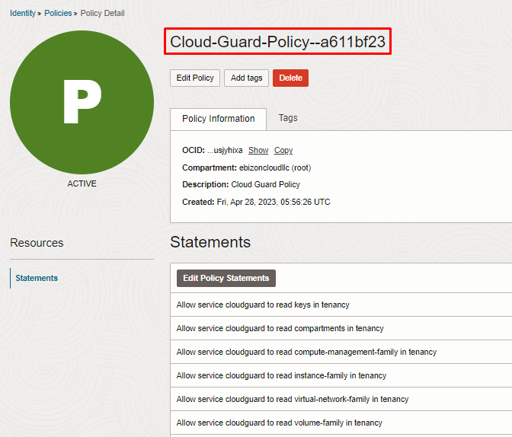

Follow 2 steps to destroy the Cloud Guard

Create a destroy job in Resource Manager to release resources associated with a stack and clean up the tenancy. Once destroyed data cannot be recovered from resources.

If you want to destroy this stack,
Step 1:
Go to OCI Console Identity & Security Cloud Guard Settings Disable Cloud Guard

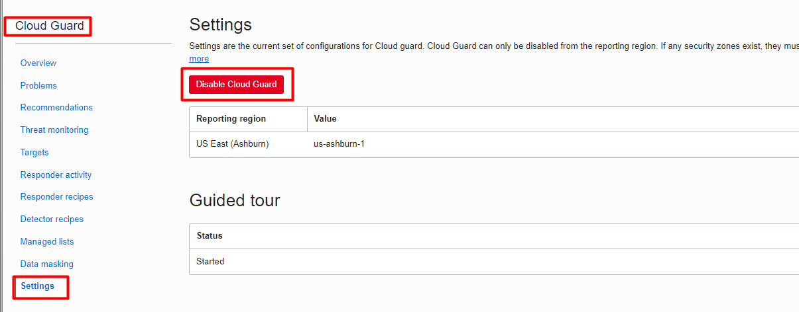

Step 2: To Destroy the stack
Go to OCI Console Developer Services Resource Manger <Select the stack> Destroy

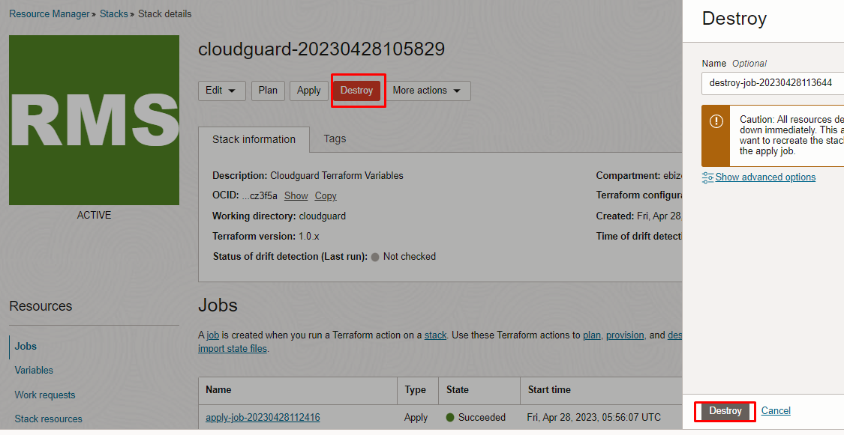

# END #

